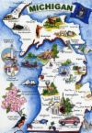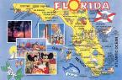
Trivia Pursuit Game
Create 20 trivia card questions about your state.
What you’ll need:
- Colorful markers
- 3x5 index cards
- Binder Ring
Step 1: Brainstorm 20 facts about your state that you want others to know.
Step 2: In “Jeopardy-like Style” create 20 answers about the facts you have chosen and write on the front of the index card.
Step 3: On the back of each index card write the question that corresponds to the answer
Step 4: Decorate and organize your cards
Step 5: Create a title card with a picture of your state, name of the state and your name. Punch a hole in the upper left-hand corner of each card and place on the binder ring starting with the title card.

